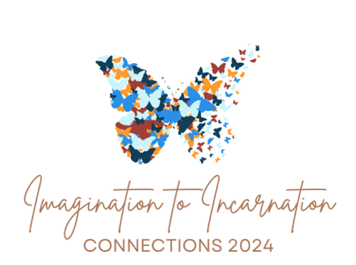
Welcome into the Story of CBK
We too are learning to tell our story more fully, and our hope grows in your attendance at this year’s conference and your continued engagement in the work of being known. I’d like to take a moment to invite you into that story …
The Center for Being Known (CBK) emerged as a response to an invitation to consider how the implications of being known (in all its range) could be made more available to more people across multiple vocational domains at a reasonable cost. CBK is imagined as the organizational manifestation of a movement rather than being limited to the work of an individual. It has the capacity to extend beyond individuals to institutions in such a way that leads to connection, courage, and creativity in sustainable, embodied ways. We long to invite people to join us at the intersection of Christian spiritual formation and interpersonal neurobiology for the purpose of creating new artifacts of goodness & beauty in the world; of extending the Eden blessing into the wilderness of our lives, just as Shane did.
After spending time in prison for embezzlement (using stolen money from his company on high-stakes gambling), Shane, who was on the finance fast track to the C-Suite, found himself in the wilderness in virtually all areas of his life. He had a job working for a landscape architect but no hope of returning to finance. His social circle was limited to his ongoing efforts in Gamblers Anonymous, and he had come from a family with sustained generational trauma as his maternal grandmother had died when his mother was four years old. His mother had a great fear of being left, which manifested in how tightly she clung to her own children and resulted in Shane seeking ways to escape the suffocation he felt from her. His compensation for this relational distress resulted in a gambling addiction.
His journey to being known began with a desire to be rid of his addiction, but hope is not something one forms by being rid of anything. Durable hope is formed by directing attention to something that does not yet exist. In a confessional community context, Shane began to experience feeling felt. His hope became linked to his community. He was “hoping” in a person, in a collective body of persons. And the Person behind all of this was Jesus. Jesus, as embodied by the others in the room. Jesus in the very form in which he promised he would be with us: in his body and in the Spirit. Shane was able to anticipate a hopeful future because of repeated experiences of feeling seen, soothed, safe, and secure with people serving as Jesus’ representatives. He built the courage to speak with the landscaping company owner about advising employees on finances and investments, which eventually led to Shane opening his own financial planning firm, a new act of creation and outpost of goodness and beauty that Shane could never have imagined in the privacy of his own mind.
CBK seeks to multiply these experiences. The CBK Association and Connections Conference are designed to facilitate connection and broaden our imaginations for those areas where we can create greater wholeness for individuals, families, communities, and organizations. Confessional communities serve as a forum to experience telling our stories more vulnerably while experiencing others’ stories as well. These increasing connections translate into greater opportunities for CBK to extend its work into areas of life not yet imagined. Thanks for coming and for your willingness to imagine with us!

